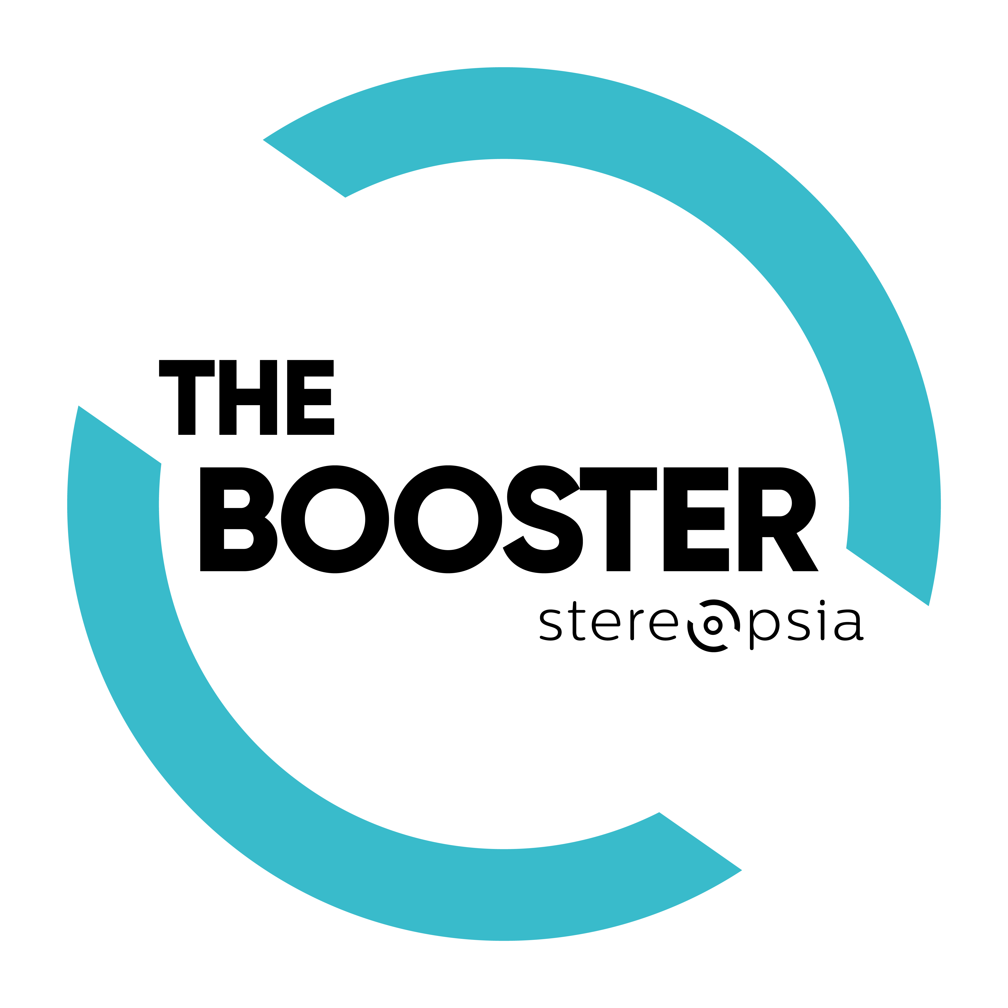
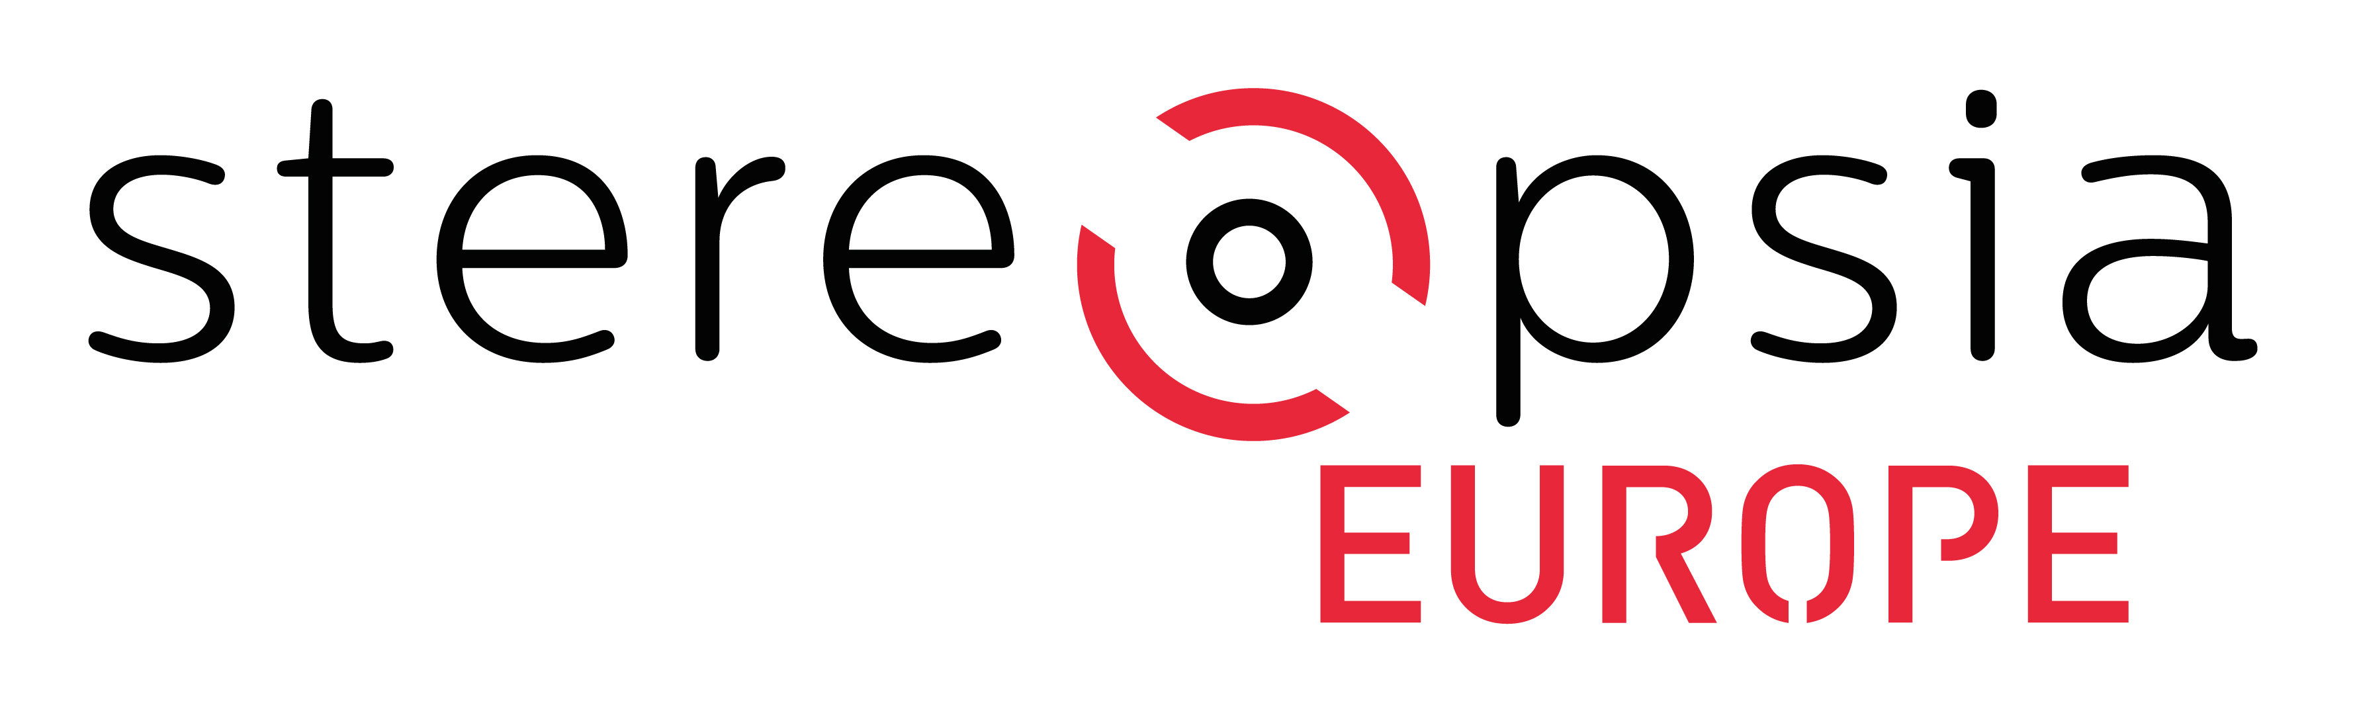

THE BOOSTER 2021
SUBMISSION FORM
Submission deadline: 30 September 2020

PROJECT HOLDER

First Name:
Last Name:
Bio (100 words):

Email:
Phone number:
Country:
Production Company:
Website:

PROJECT INFORMATION

Working Title:
Log Line (1-2 sentences):

Synopsis (350 words max):

Genre:

Length (in minutes):

Language(s):

Statement by the Project holder (350 words max) - Please describe the motive and vision behind making your project.

Technical approach (250 words) - Please describe the techniques or technologies you plan to use to shoot your film (360° camera, volumetric capturing, computer animation, hybridation of different techniques) and specify your treatment of the sound.

Format & Experience (250 words) - Please describe how you imagine your work to be experienced and distributed, which device(s) or installation would be the most relevant, who is your target audience, etc.

Budget (150 words max) - Please provide a breakdown of your project’s expenses. If you already have either a top sheet, or a comprehensive line item budget, feel free to attach it to your submission. Please note that we understand if your project is in early development, you may not yet have a detailed budget. However, please share as much as you can about your project budget. Finally, let us know of any funds you have raised to date, and any future fundraising plans you have.

Link to the teaser/trailer of the project (optional) - Please provide the password if any:

Visual elements showing key art of project (optional - 5 pages max in PDF):

TEAM INFORMATION

Scriptwriter:
Director:
Producer(s):
Other(s) - Please add any other key member of your team that would be relevant to mention in this submission and detail his/her role (technical director, developer, artist, performer, etc.):

Work Experience (150 words max) - Please describe the overall qualifications, work experience, and expertise of the team you have assembled to complete this project. Are you a first-time filmmaker? Have you lined up producers, cinematographers, or other members of the film team to support you?

Link to previous work(s) from Project holder (optional):

QUESTIONS

Why do you submit your project to The Booster (150 words max)

What are you expecting from your participation at The Booster & Stereopsia? (150 words max)

How did you hear about The Booster? (1-2 sentences)

CONTACTS

Sylvain Grain  sylvain@stereopsia.com  Alexandra Gérard  alexandra@stereopsia.com | Stereopsia: www.stereopsia.com  The Booster: europe.stereopsia.com/en/program/booster

